

**MAHARASHTRA STATE BOARD OF TECHNICAL EDUCATION (MUMBAI)**

**“ Company ERP Management System ”**

**A Project Report**

**Submitted by:**

| **Sr. No.** | **Name of Student** | **Exam Seat No.** |
| --- | --- | --- |
| **1)** |  | **:____________** |
| **2)** |  | **:____________** |
| **3)** |  | **:____________** |

In partial fulfillment for the award of the Diploma Engineering

in the course Computer Technology

at



**Department of Computer Technology**

**K. K. WAGH POLYTECHNIC, NASHIK**

**Academic Year 2021-22**



**MAHARASHTRA STATE BOARD OF TECHNICAL EDUCATION, (MUMBAI)**

**A**

**Project Report**

**on**

**“Company ERP Management System”**

***Submitted by:***

| | **Sr. No.** | **Name of Student** | **Exam Seat No.** | | --- | --- | --- | | **1)** |  | **:____________** | | **2)** |  | **:____________** | | **3)** |  | **:____________** | |  |  |
| --- | --- | --- | --- | --- | --- | --- | --- | --- | --- | --- | --- | --- | --- | --- |

***Under the Guidance of:***

**Name of Guide: Prof.**

**Designation: Lecturer in Computer Technology**



**Department of Computer Technology**

**K. K. WAGH POLYTECHNIC, NASHIK**

**Academic Year 2021-22**

Karmaveer Kakasaheb Wagh Education Society’s

**K. K. WAGH POLYTECHNIC**

Hirabai HaridasVidyanagari, Amrutdham, Panchavati, Nashik-422003, Maharashtra

|  |  |  |
| --- | --- | --- |

This is to certify that the Project Group of Students:

1. Enrolment No._________ Seat No. _______
2. No._________ Seat No. _______
3. Enrolment No._________ Seat No. _______

From the institute K. K. Wagh Polytechnic, Nashik, Course– Computer Technology has completed the Academic Project of their final year having Title:  **Company ERP Management System** during the Academic Year 2021-22. The project was completed by individuals working in a group consisting of _____ persons under the guidance of the Faculty Guide.

Date: / / 2022 Place: Nashik

Internal Faculty Guide HOD- Computer Technology

(Sign of Mentor from the industry) Prof. P. T. Kadave

Name:  Principal

Contact No:

**ACKNOWLEDGEMENT**

With a deep sense of gratitude, we would like to thank all the people who have lit our path with their kind guidance. We are very grateful to these intellectuals who did their best to help during our project work.

It is our proud privilege to express a deep sense of gratitude to Prof. **P. T. Kadave,** Principal, K.K. Wagh Polytechnic, Nashik for his comments and kind permission to complete this project. We remain indebted to **Prof. G.B. Katkade,** Head of Computer Technology Department for his timely suggestion and valuable guidance.

The special gratitude goes to our Internal Guide **Mrs.,** staff members, technical staff members, of the Computer Technology Department for his expensive, excellent and precious guidance in completion of this work. We thanked all the class colleagues for their appreciable help for our working project.

With various industry owners or lab technicians to help, it has been our endeavour throughout our work to cover the entire project work.

We are also thankful to our parents who provided their wishful support for our project completion successfully. Lastly we thank all our friends and the people who are directly or indirectly related to our project work.

Names of Students

1) TYCM

2) TYCM

3) TYCM

Date : / / 2022 (Academic Year : 2021-22)

**Vision & Mission**

| **Institute Vision:-** | Strive to empower students with Quality Technical Education. |
| --- | --- |
| **Institute Mission :-** | Committed to developing students as Competent and Socially Responsible Diploma Engineers by inculcating learning skills, values and ethics, entrepreneurial attitude, safe and eco-friendly outlook and innovative thinking to fulfill aspirations of all the stakeholders and contribute in the development of Organization, Society and Nation. |
| **Department Vision :-** | (Version – 1.1)  To impart quality technical education for development of technocrats. |
| **Department Mission :-** | (Version – 1.2)  M1- To provide quality education and facilities for students to help them to achieve higher academic career growth.  M2- To impart education to meet the requirements of the industry and society by technological solutions.  M3- Develop technical & soft skills through co–curricular and extracurricular activities for improving personality. |
| **Program Educational Objectives:- (PEOs)** (Version – 1.2)  PEO1: Provide socially responsible, environment friendly solutions to Computer engineering related broad-based problems adapting professional ethics.  PEO2: Adapt state-of-the-art Computer engineering broad-based technologies to work in multi-disciplinary work environments.  PEO3: Solve broad-based problems individually and as a team member communicating effectively in the world of work | |
| **Program Specific Outcome:- (PSOs)** (Version – 1.2)  PSO 1: **Computer Software and Hardware Usage:** Use state-of-the-art technologies for operation and application of computer software and hardware.  PSO 2: **Computer Engineering Maintenance:** Maintain computer engineering related software and hardware systems. | |
| **Course Outcomes:** | |
| **Program Outcomes:- (POs)** (Version – 1.2)  PO 1: Basic knowledge: Apply knowledge of basic mathematics, sciences and basic engineering to solve the broad-based Computer engineering problem.  PO 2: Discipline knowledge: Apply Computer engineering discipline - specific knowledge to solve core computer engineering related problems.  PO 3: Experiments and practice: Plan to perform experiments and practices to use the results to solve broad -based Computer engineering problems.  PO 4: Engineering tools: Apply relevant Computer technologies and tools with an understanding of the limitations.  PO 5: The engineer and society: Assess societal, health, safety, legal and cultural issues and the consequent responsibilities relevant to practice in the field of Computer engineering.  PO 6: Environment and sustainability: Apply Computer engineering solutions also for sustainable development practices in societal and environmental contexts and demonstrates the knowledge and need for sustainable development.  PO 7: Ethics: Apply ethical principles for commitment to professional ethics, responsibilities and norms of the practice also in the field of Computer engineering.  PO 8: Individual and team work: Function effectively as a leader and team member in diverse/ multidisciplinary teams.  PO 9: Communication: Communicate effectively in oral and written form.  PO10: Life-long learning: Engage in independent and life-long learning activities in the context of technological changes in the Computer engineering field and allied industry. | |

**Abstract**

This study is to analyse the impact of the Enterprise Resource Planning system in Human Resource management practices including recruitment and selection, training and development and compensation and benefits and then HRM practices impact on organizational productivity in terms of employee’s performance. Stratified Random sampling method was taken for this descriptive research. Stratified Random Sampling method was used and 250 samples were used for this study. Questionnaires consisted of different items related to ERP product, HRM activities and organizational productivity. The targeted respondents were the employees who are using ERP irrespective of their position or grades in those particular organizations. Results show the ERP implementation has a negative relationship with recruitment and selection and also not showing relation with compensation and benefits but having a positive relationship regarding training and development of organizational employees. Recruitment and selection shows negative relation whereas, compensation and benefits and training and development shows positive relationship with organizational productivity. Study limitation includes small sample size, time constraints and other human resource activities.

***Keywords****: Web Application, Enterprise Resource Planning, Employee performance*

**Table of Content**

| **Sr. No.** | **Name of topic** | **Page no.** |
| --- | --- | --- |
| 1 | Certificates | I |
| 2 | Acknowledgement | II |
| 3 | Abstract | III |
| 4 | Table Index | IV |
| 5 | Figure Index | IV |
| 6 | Introduction | 1 |
| 7 | Literature Survey | 3 |
|  | 1. Existing System | 3 |
|  | 2. Proposed System | 4 |
| 8 | Analysis and Feasibility | 5 |
| 9 | Project Design | 7 |
| 10 | Module Analysis | 15 |
| 11 | System Requirement | 18 |
| 12 | Software Development Methodology | 20 |
| 13 | Software Testing | 23 |
| 14 | Future Scope | 28 |
| 15 | Conclusion | 28 |
| 16 | References | 30 |

**Index of Figures**

| **Fig. No.** | **Name of figure** | **Page no.** |
| --- | --- | --- |
| 4.1.1 | System Diagram | 8 |
| 4.1.2 | Block Diagram | 9 |
| 4.2.1.1 | DFD Level 0 | 11 |
| 4.2.1.2 | DFD Level 1 | 12 |
| 4.2.1.3 | DFD Level 2 | 13 |
| 4.2.2 | UML Diagram | 14 |
| 4.3.5 | Input/output Model | 18 |

**Introduction**

The proposed project “Company ERP Management System” has been developed to overcome the problems faced in the practice of manual systems. This software is built to eliminate and in some cases reduce the hardships faced by the existing system. Moreover this system is designed for the particular need of the company to carry out its operations in a smooth and effective manner. This web application is reduced as much as possible to avoid errors while entering data. It also provides an error message while entering invalid data. It is user-friendly as no formal knowledge is required to use the system. Human resource challenges are faced by every organization which has to be overcome by the organization. Every organization has different employee and payroll management needs. Therefore I have designed an exclusive Employee and payroll Management System that is adapted to the organization’s Managerial Requirements. Payroll system is the heart of any Human Resource System of an organization. The solution has to take care of the calculation of salary as per rules of the company, income tax calculation and various deductions to be done from the salary including statutory deductions like Income tax and provident fund deductions. It has to generate pay-slip, cheque summary and reports.It is understood that we are tired of managing thousands of odd papers, pay slips, payroll reports, salary details and so on. Imagine that we have a payroll processing system which will generate our pay slips and payroll reports within seconds. We can help others automate your payroll system by developing a customized payroll application.

**1.1 Literature Survey**

Individual performance is in reality the actual performance of the individuals which are dealing and handling this system (Gattiker, T.F. and D.L. Goodhue, 2005). Employee’s satisfaction with the system can enhance the organizational impact and information quality can increase the usefulness of the system (Seddon, P.B. and M.Y. Kiew, 2007). Proper information delivery format, communication, customer focus activities, salary and better working conditions also affect the employee’s intention to leave or not (Boselie, P. and T.V. Wiele, 2002). Organizations which are high risk oriented are not much focusing on the short-term incentive and show poor performances as compared to those which have greater risk but they are giving importance towards more incentive.Milkovich G.T., 1998). HRM consist of activities like, hiring, training, development, compensations, benefits, record management, retirement etc (Tadinan, H., 2005). Enterprise Resource Planning software is very much effective in handling the different functions for manufacturing organizations such as material purchase and inventory handling, order tracking, data related to receivable and payables, warehousing, human resource management, production, transportation, ledger maintenance etc. Training also helps for a better understanding of the system (Compeau, D. and C. Higgins, 1995). Education and training also affect the success and failure of ERP implementation. Those organizations, which used ERP without much effort, have low commitment to change and they did not actively participate in training employees for proper handling. They have to bear high costs in training for those people who are reluctant. If employees are properly educated about what is expected from their side and also train them accordingly then failure results can convert into success. All the human resource functions of the organizations when handled in an electronic way can give the access of information to the members using ERP software.

**1.2 Existing System:**

The biggest problem which is faced while using the system is user interface,due to complex business rules, users face various difficulties while handling the existing system. Even they are not getting help on how to deal with errors if occurred while working with the system.Maintaining employees records was not an easy task and while preparing final payroll records,each employee needs to be categorized as per their job category. Its accounting module has to take help of a tally package and whatever information retrieved is used for preparing pay slips for each employee of the organization.It also takes a very long time to make salary slips. Due to manual processes, it takes a very long time, in turn it delays the salary distribution.This is a big problem to manage when salary is not generated in time. The other main problem is error, even with double cross check here or there some errors will happen, this again create large problem.

**1.3 Proposed System:**

The proposed project “Company ERP Management System” has been developed to overcome the problems faced in the practice of manual systems. This software is built to eliminate and in some cases reduce the hardships faced by the existing system. Moreover this system is designed for the particular need of the company to carry out its operations in a smooth and effective manner.This web application is reduced as much as possible to avoid errors while entering data. It also provides an error message while entering invalid data. It is user-friendly as no formal knowledge is required to use the system.The project is divided into two categories: Admin, Employee Login. In an overview of this web app, the manager has full control of the system, whereas the admin can only manage employee records.This system is developed using PHP and MYSQL.This is the web application .In this system Admin gets logged in by valid username and password. Admin can add new Employees, add new Department, add new Pay Grade for the employees.Add stock ,add Admin can set the ‘from’ and ‘to’ date worked by an employee in a department with specific pay grade. The Admin can generate an automated monthly salary of an employee. The admin can view all the past records of any recorded employee.admin can manage all stock in company.admin can manage all employee records.

**Analysis and Feasibility**



**Feasibility Study:**

For all the new systems, the engineering process should act with the feasibility study. The input to the feasibility study is only the description of the system and how it will be used within an organization. The result of the feasibility study should be a report, which recommends whether it is worth carrying with the requirement engineering and the system development process.

**Feasibility study considerations are**:-

The general types of feasibility study are as follows: -

1. Economical Feasibility
2. Technical Feasibility
3. **Economic Feasibility:**

Economic analysis is the most frequently used method for evaluating the effectiveness of the system. More commonly known as cost analysis, the procedure to determine the benefits and savings that are expected from a system, the labour expenses are reduced.

The cost for development of the system is very moderate. The cost of the hardware and software for management is at present economical. The benefits in turn reduce a lot of manual paper work. The development cost in future will be putting the system on its extension.

1. **Technical Feasibility:**

The technical feasibility involves financial consideration to accommodate the technical enhancement, with the existing provision of computerization; the work can be completed efficiently. The project is implemented in PHP which is user friendly, efficient and error free.

The PHP MYSQL which supports any operating system (OS) in which the project was implemented made time such less. The computerized material planning process is to be developed in PHP, which is free of cost as well as platform Independent.

**Project Requirements**



For implementing the application, sample data from the company has been taken.

* **Area of implementation:**

In this project, we used data Mining as an area of implementation for company erp management system

* **Project Functional Requirements:**
* Operating System: Windows 7
* Technologies used:PHP,MYSQL
* Database: MySQL database
* **Hardware requirements:**
* **Project Development:**

These requirements are separated based on whether you are developing the app or running the app on a device.

For development

* Operating System Microsoft Windows 7
* Platform Sublime Text Framework
* Tools: Sublime Text 3
* Technologies used :PHP ,MYSQL
* Language: PHP
* Database MySQL database
* Software used Sublime Text 3
* **Project Operations:**

There is no restriction on the number of users to be added to the database Hardware requirements.

* Operating System Windows XP Vista 7/8
* Intel Core i3
* Memory 4GB and above
* Capacity 64GB of hard drive
* Others network interface card, mouse, keyboard and monitor
* **Software requirements:**
* **Project Development:**

| **Software** | **Specifications** |
| --- | --- |
| Xampp Server | 3.2.4 |
| Sublime Text 3 | 3.2.2 |
| Operating System | Windows 7 |

* **Project Operations:**

#### **Development Tools**

#### **I PHP**

The PHP Hypertext Preprocessor (PHP) is a programming language that allows web developers to create dynamic content that interacts with databases. PHP is basically used for developing web based software applications. This tutorial helps you to build your base with PHP.

Why to Learn PHP?

PHP started out as a small open source project that evolved as more and more people found out how useful it was. Rasmus Lerdorf unleashed the first version of PHP way back in 1994.

#### **➢ Features**

1. PHP is a recursive acronym for "PHP: Hypertext Preprocessor".
2. PHP is a server side scripting language that is embedded in HTML. It is used to manage dynamic content, databases, session tracking, and even build entire e-commerce sites.
3. It is integrated with a number of popular databases, including MySQL, PostgreSQL, Oracle, Sybase, Informix, and Microsoft SQL Server.
4. PHP is forgiving: PHP language tries to be as forgiving as possible.
5. PHP Syntax is C-Like.



#### **Sublime Text 3**

Sublime Text is a shareware cross-platform source code editor with a Python application programming interface (API). It natively supports many programming languages and mark-up languages, and functions can be added by users with plugins, typically community-built and maintained under free-software licenses. Sublime Text is powerful where you need it to be, but simple and out of your way at the same time. Great keyboard shortcuts and multi-selection options. Great package manager installation process for easily extending functionality.

##### **➢ Features**

1. Auto completion, Syntax Highlight, Code Folding
2. Customizability
3. Lightweight, Fast and Stable
4. Powerful Search



#### **2. Database**

##### **MYSQL**

MySQL is [free and open-source software](https://en.m.wikipedia.org/wiki/Free_and_open-source_software) under the terms of the [GNU General Public License,](https://en.m.wikipedia.org/wiki/GNU_General_Public_License) and is also available under a variety of [proprietary](https://en.m.wikipedia.org/wiki/Proprietary_software) licenses. MySQL was owned and sponsored by the [Swedish](https://en.m.wikipedia.org/wiki/Sweden) company [MySQL AB,](https://en.m.wikipedia.org/wiki/MySQL_AB) which was bought by [Sun Microsystems](https://en.m.wikipedia.org/wiki/Sun_Microsystems) (now [Oracle Corporation)](https://en.m.wikipedia.org/wiki/Oracle_Corporation).

In 2010, when Oracle acquired Sun, Widenius [forked](https://en.m.wikipedia.org/wiki/Fork_(software_development)) the [open-source](https://en.m.wikipedia.org/wiki/Open-source) MySQL project to create [MariaDB.](https://en.m.wikipedia.org/wiki/MariaDB) MySQL is a component of the [LAMP](https://en.m.wikipedia.org/wiki/LAMP_(software_bundle)) [web application](https://en.m.wikipedia.org/wiki/Web_application) [software stack](https://en.m.wikipedia.org/wiki/Software_stack) (and [others)](https://en.m.wikipedia.org/wiki/List_of_AMP_packages), which is an acronym for [Linux,](https://en.m.wikipedia.org/wiki/Linux) [Apache,](https://en.m.wikipedia.org/wiki/Apache_HTTP_Server) MySQL, [Perl](https://en.m.wikipedia.org/wiki/Perl)[/PHP](https://en.m.wikipedia.org/wiki/PHP)[/Python.](https://en.m.wikipedia.org/wiki/Python_(programming_language)) MySQL is used by many database-driven web applications, including [Drupal,](https://en.m.wikipedia.org/wiki/Drupal) [Joomla,](https://en.m.wikipedia.org/wiki/Joomla) [phpBB,](https://en.m.wikipedia.org/wiki/PhpBB) and [WordPress.](https://en.m.wikipedia.org/wiki/WordPress) MySQL is also used by many popular [websites,](https://en.m.wikipedia.org/wiki/Website) including [Facebook,](https://en.m.wikipedia.org/wiki/Facebook) [Flickr,](https://en.m.wikipedia.org/wiki/Flickr) [MediaWiki,](https://en.m.wikipedia.org/wiki/MediaWiki) [Twitter,](https://en.m.wikipedia.org/wiki/Twitter) and [YouTube.](https://en.m.wikipedia.org/wiki/YouTube)

MySQL is offered under two different editions: the [open source](https://en.m.wikipedia.org/wiki/Open-source_software) MySQL Community Server and the proprietary [Enterprise Server.](https://en.m.wikipedia.org/wiki/MySQL_Enterprise) MySQL Enterprise Server is differentiated by a series of proprietary extensions which install as server plugins, but otherwise share the version numbering system and are built from the same code base.

##### **➢ Features**

1. Cross-platform support
2. [ACID](https://en.m.wikipedia.org/wiki/Atomicity,_consistency,_isolation,_durability) compliance
3. [SSL](https://en.m.wikipedia.org/wiki/Secure_Sockets_Layer) support
4. Query [caching](https://en.m.wikipedia.org/wiki/Cache_(computing))

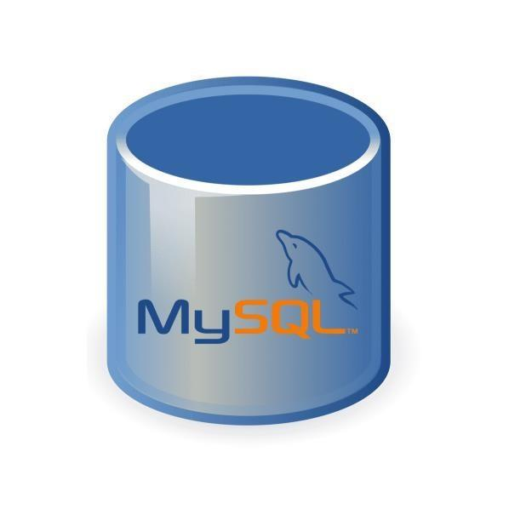

**Project Design**



**4.1 Design Concept:**

This project is based on the database, web based techniques. To keep the records in the database it uses MySQL software which is one of the best and the easiest databases to keep information. This project uses Bootstrap ,html,css as the front-end web based application which is a php based Programming and has connectivity with MySQL. This system is developed using PHP and MYSQL.This is the web application .In this system Admin gets logged in by valid username and password. Admin can add new Employees, add new Department, add new Pay Grade for the employees,also add stock of the company Admin can set the ‘from’ and ‘to’ date worked by an employee in a department with specific pay grade. The Admin can generate an automated monthly salary of an employee. The admin can view all the past records of any recorded employee.

**4.1.1 System Diagram:**

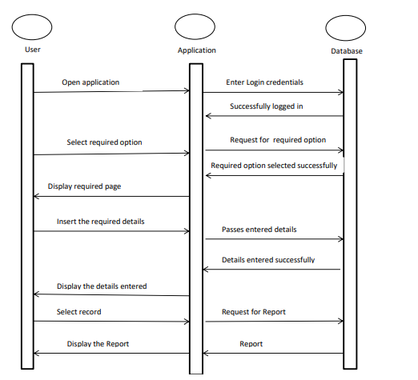

**Fig No 1: System Diagram**

**4.1.2 Block Diagram**

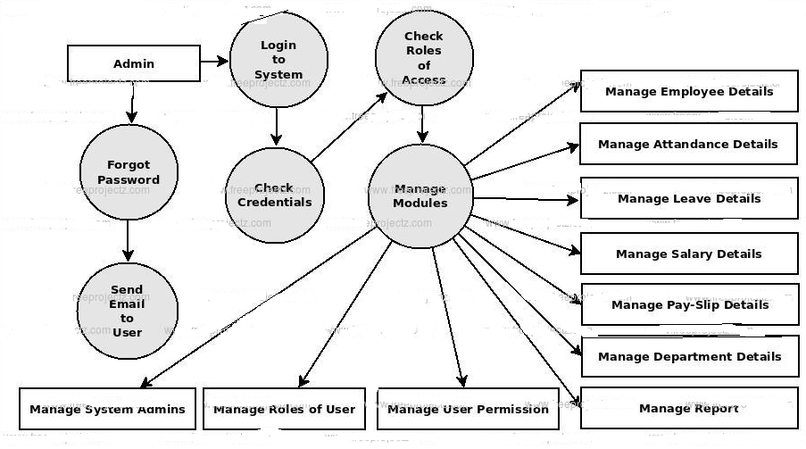

**Fig No 2: Block Diagram**

**4.2 Component Design, DFD Diagram and UML Diagram:**

**4.2.1 Data Flow Diagram**

**DFD Diagram:**

In the design phase the architecture is established. This phase starts with the requirement document delivered by the requirement phase and maps the requirements into architecture. The architecture defines the components, their interfaces and behaviours. The deliverable design document is the architecture.

The design document describes a plan to implement the data flow diagram (level 0) shown in fig 3. Level 0 includes the overall functioning of the system. A data flow diagram at its simplest is a representation of a flow of the current system. A data flow diagram shows the steps of all the execution of the data and the processes.

Figure 4. shows Data flow diagram (level 1). Level 1 includes the brief description of the image processing module, it shows the conversion of video to frame and edge detection. And A data flow diagram shows the steps of all the execution of the data and the processes. Figure 5. shows Data flow diagram (level 2).

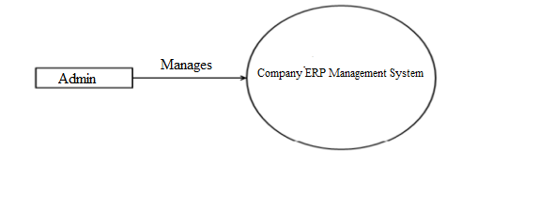

**Fig No 3.: DFD Level 0**

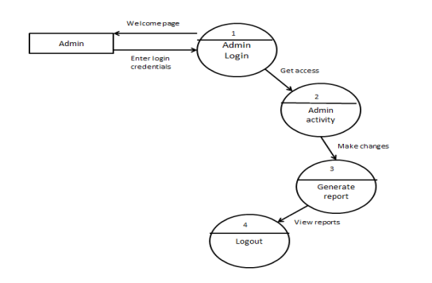

**Fig No 4: DFD Level 1**

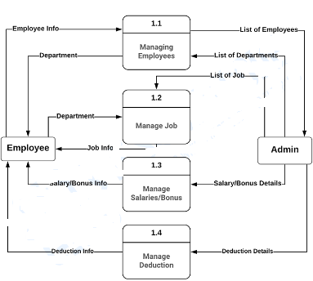

**Fig No 5: DFD level 2**

**4.2.2 UML Diagram:**

UML is the Unified Modelling Language, a standard that defines the rules and notation for specifying software systems. The notation supplies a rich set of graphic elements for modelling object-oriented elements, and the rules say how those elements may be connected and used.

UML is not a prescriptive process for creating software systems - it does not supply a method or process, simply the language. You can therefore use UML in a variety of ways to specify and develop your software engineering project. Enterprise Architect supports many different kinds of UML elements (as well as some custom extensions).

Together with the links and connectors between elements, these form the basis of the model. In addition to the base UML elements, the modelling environment can be extended using UML Profiles. A Profile is a set of stereotyped and tagged elements that together solve some modelling problem or scenario. Examples are UML Profiles for modelling XML Schema or Business Process Modelling.

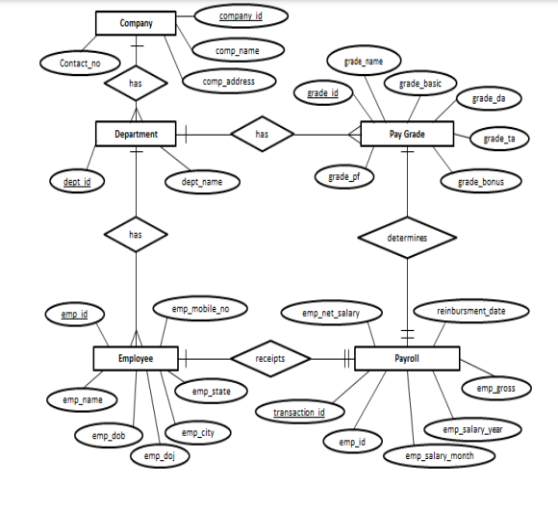

**Fig No 6: UML Diagram**

**4.3 Module Analysis**

**4.3.1 Module:**

1. Signup
2. Creating Profile
3. Admin
4. Employee
5. Stock
6. Purchase

**4.3.2 Purpose of Module:**

1. **Signup Module:**

At first theTutors/parents need to register themselves. After registering, registered candidates can log in by giving their username and password. Each and every user has their unique username and password.

1. **Creating Profile:**

After logging in candidates needed to choose one category between teachers or tutors. And need to fill up the form accordingly.

1. **Admin**

The Admin gets logged in by valid username and password. Admin can add new Employees, add new Department, add new Pay Grade for the employees. Admin can set the ‘from’ and ‘to’ date worked by an employee in a department with specific pay grade. The Admin can generate an automated monthly salary of an employee. The admin can view all the past records of any recorded employee

1. **Employee:**

In this module Employee login with username and password Employee can view his/her own profile Employee can punch in and punch out Logout for Employee Report of the project Employee Time & Attendance Management System Report for Admin process Report for Employee process

**4.3.3 Algorithm:**

**Agile Algorithm**

Itis one of the simplest and effective processes to turn a vision for a business need into software solutions. Agile is a term used to describe software development approaches that employ continual planning, learning, improvement, team collaboration, evolutionary development, and early delivery. It encourages flexible responses to change.

**The agile algorithm emphasizes four core values.**

1. Individual and team interactions over processes and tools
2. Working software over comprehensive documentation
3. Customer collaboration over contract negotiation
4. Responding to change over following a plan

**4.3.4 Procedural steps:**

1. Start

2. Register Admin

3. Login

4. Admin Manage Employee details and add or manage employees .

5. Admin Can Manage reports

6.Admin can manage and view attendance ,salary,leaves,stock,Purchase etc

7. End

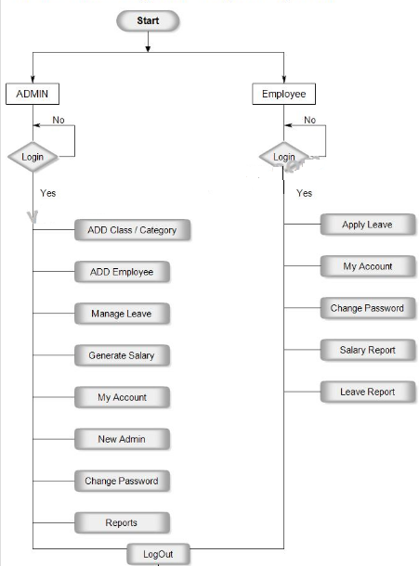

**4.3.5 User interface designs:**

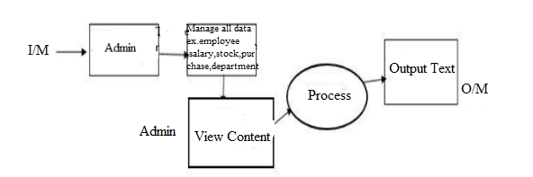

**Fig No 7: Input/output Model**

**System Requirements:**

**Hardware Requirement for Development of Project:**

Processor : Intel CORE i3

RAM : 4GB

Hard Disk : 64GB

**Software Requirement for Development of Project:**

Operating System : Microsoft Windows-7.

Software Package : PHP,,MySQL

**Advantages of this Project:**

1. It is cost effective as the user controls the web application himself and does not go for professional service.
2. It saves time as it speeds up every aspect of the employee database management and payroll process with a range of automated features.
3. It is secure as the employee database and the payroll process is managed by the admin in house rather than sending private information to a third party.
4. Validating procedures and checks restrict users from making mistakes.
5. The software is easy to use and is user friendly so no expertise is required.
6. The calculations are automated so no chance of error

**Limitations/Constraints of Project:**

* 1. Requires Internet connection.
* **Software Development Methodology**

Methodology is a formalized approach to implement the System. There are many different systems development methodologies, and each one is unique based on the order and focus it places on each SDLC phase. Some methodologies are formal standards used by government agencies, while others have been developed by consulting firms to sell to clients.

Many organizations have internal methodologies that have been honed over the years, and they explain exactly how each phase of the SDLC is to be performed in that company. There are many ways to categorize methodologies. One way is looking at whether they focus on the business process or the data that support the business.

There are three types of system development methodologies, it is called Structured Design, RAD (Rapid Application Development), and Agile Development.

* **Types of Software Development Methodologies**
* **Structured Design**

This is the first type of system development; it was introduced in the 1980s. This methodology adopts the formal step by step approach to the SDLC, it moves logically from one phase to another phase.

* **Waterfall Model**

This is the original structured design of methodology, with this methodology, the analyst and users proceed in sequence from one phase to the next phase. The key deliverables for each phase are typically very long and are presented to the project sponsor for approval as the project moves from phase to phase. This methodology is referred to as waterfall development because it moves forward from phase to phase in the same manner as a waterfall.

**Advantages of using waterfall model:**

* It identifies system requirements long before programming begins
* It minimizes changes to the requirements as the project proceeds.

**Disadvantages of using waterfall model:**

* The design must be completely specified before programming begins
* This model required significant rework, if there are changes in the business environment, in order to go back to the initial phase need to go through each of the subsequent phases in return.
* **Parallel Development**

This model of methodology attempts to address the problem of long delay between analysis phase and the delivery of the system. Instead of doing design and implementation in sequence, it performs a general design for the whole system and then divides the project into a series of distinct sub projects that can be designed and implemented in parallel. Once all subprojects are complete, there is a final integration of the separate pieces, and the system is delivered.

**Advantage of using parallel model:**

* It can reduce the schedule time to deliver a system
* There is less chance of changes in the business environment causing rework

**Disadvantage of using parallel model:**

* The approach still suffers from problem caused by paper documents
* It adds new problem, sometimes subprojects aren’t completely independent; design decisions made in one subproject may affect another subprojects
* **Phased Development**

In this model, the overall system is divided into a series of versions that are developed sequentially. The analysis phase identifies the overall system concept, and the project team, users and system sponsors then categorize the requirement into a series of versions.

**Advantage of using phased model:**

* Quickly getting a useful system into the hands of the users
* While the system does not perform all the functions the users need at first, it does begin to provide business value sooner than if the system were delivered after completion, as is the case with waterfall or parallel methodology.

**Disadvantage of using phased model:**

* The users begin to work with the systems that are intentionally incomplete, it is critical to identify the most important and useful feature and include them in the first version, while managing user’s expectation along the way.
* **Prototyping**

In this model, it performs the analysis, design and implementation phases concurrently, and all the three phases are performed repeatedly in a cycle until the system is completed. In this methodology, the basics of analysis and design are performed, and work immediately begins on a system prototype, a “quick and dirty” program that provides a minimal amount of features.

**Advantage of using prototyping model:**

* It is very quickly providing a system for the users to interact with, even if it is not ready for widespread organizational use at first.
* Reassure the users that the project team is working on the system
* Helps to more quickly refine real requirements rather than attempting to understand a system specification on paper, the user can interact with the prototype to better understand what it can do and cannot do.

**Disadvantage of using prototyping model:**

* Its fast paced system releases challenge attempts to conduct careful, methodical analysis. This can cause problems in the development of complex systems because fundamental issues and problems are not recognized until well into the development process.

**Result**



**Login Page**

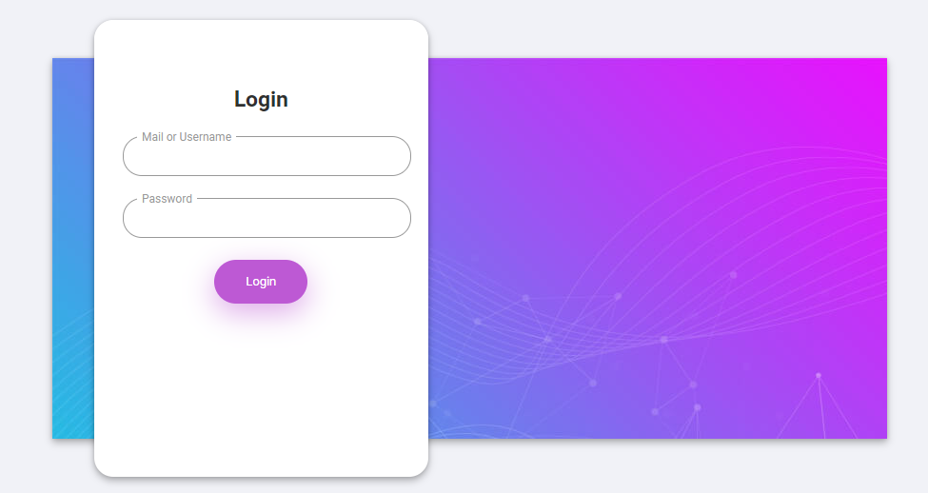

**Employee Page**

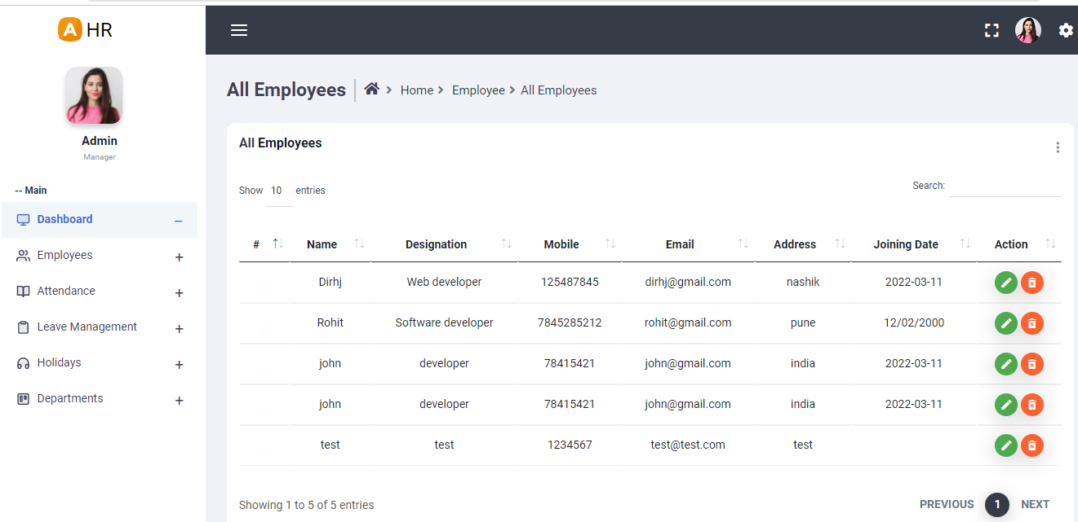

**Dashboard Page**

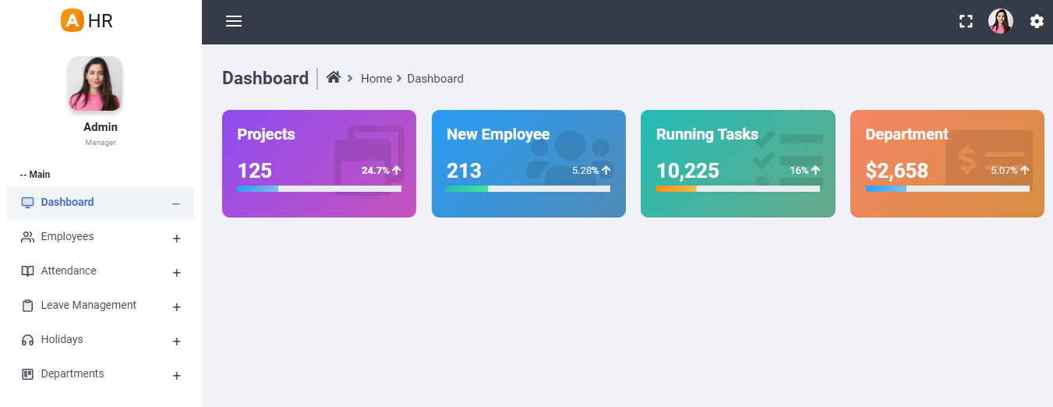

**Leave Request**

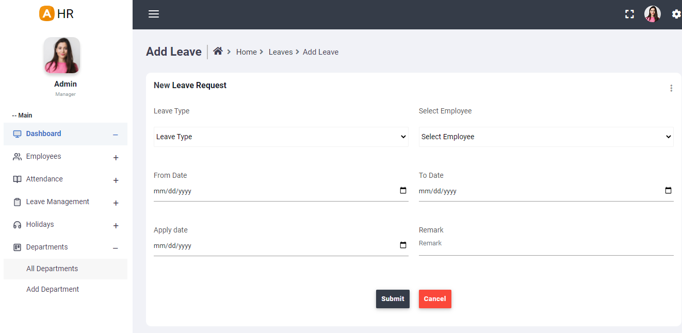

**Employee Attendance**

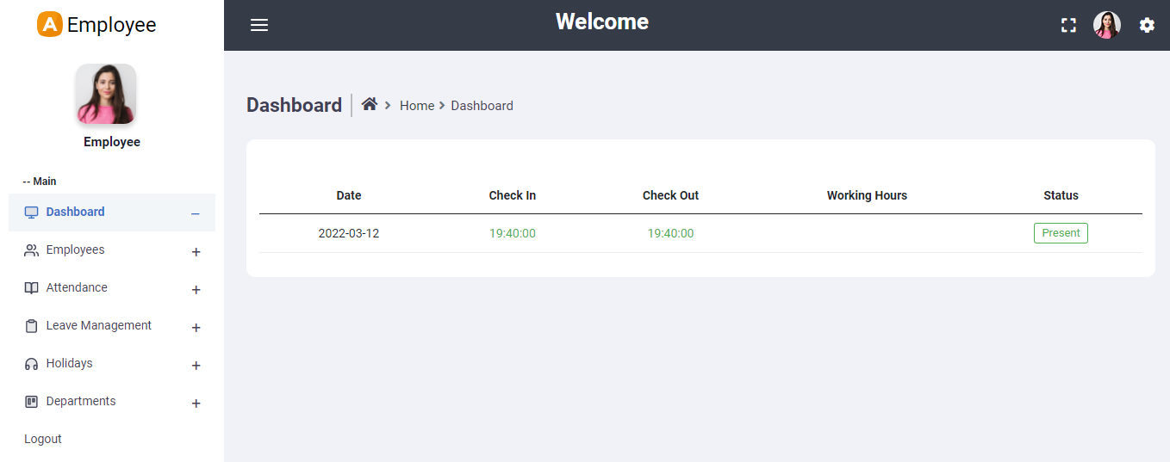

**Holiday Page**

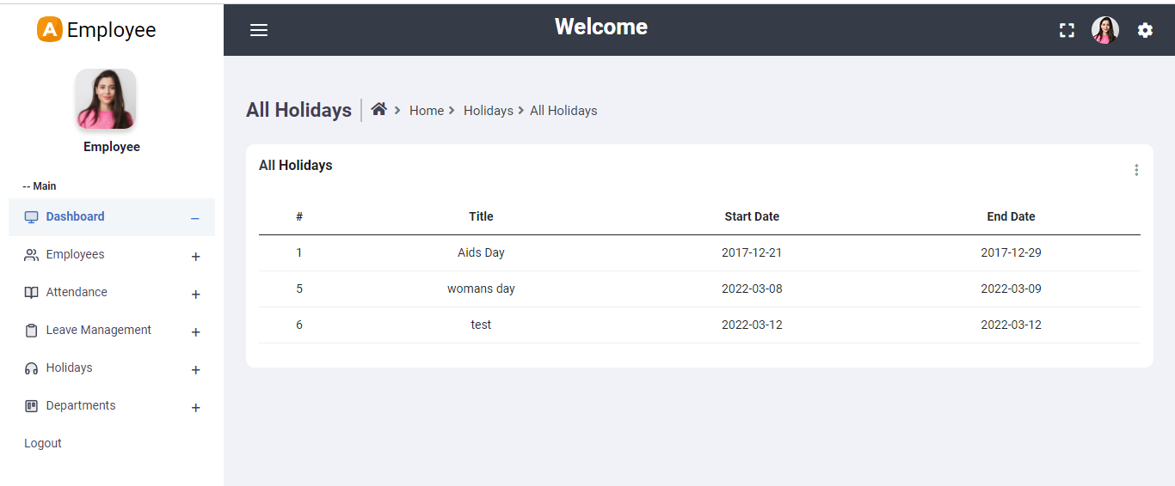

**Employee Details Page**

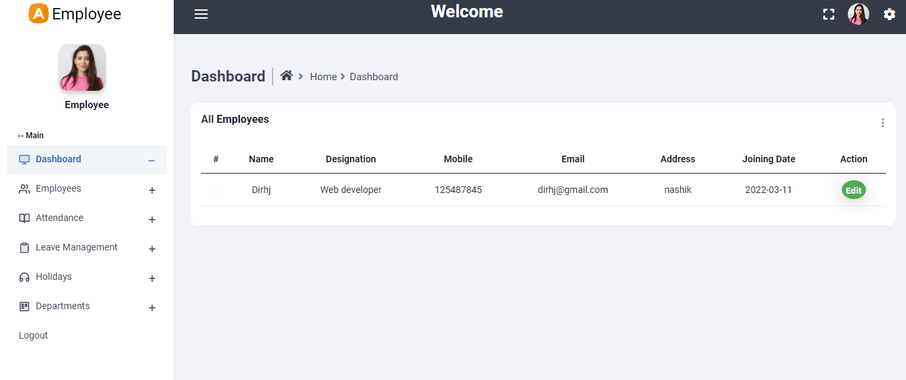

**Code**

**Software Testing**

“Testing is the process of executing a program with the intent of finding errors.” Software testing is a processor, a series of processes, designed to make sure computer code does what it was designed to do and that it does not do anything unintended.Software should be predictable and consistent, offering no surprises to users.

Purpose of testing can be quality assurance, verification and validation, or reliability estimation. Software testing is to assess and evaluate the quality of work performed at each step of the software development process. The goal of software testing is to ensure that the software performs as intended, and to improve software quality, reliability and maintainability.

* **Objectives of Software Testing**

The major objectives of software testing are as follows:

1. Finding defects which may get created by the programmer while developing the software.
2. Gaining confidence and providing information about the level of quality.
3. To prevent defects.
4. To make sure that the end result meets the business and user requirements.
5. Gain the confidence of the customers by providing them a quality product.
6. To ensure that if satisfies the BRS that is Business Requirement Specification and SRS that is System Requirement Specification.
   1. **Unit Testing**

| **Test Case Id: 0001** | | | | **Test Designed By:** | | | |  |
| --- | --- | --- | --- | --- | --- | --- | --- | --- |
| **Low/Medium/High): Medium** | | | | **Test Designed Date:** | | | |  |
| **Module Name: Status** | | | | **Test Executed By:** | | | |  |
| **Test Title: Test the Website** | | | | **Test Execution Date:** | | | |  |
| **Description:** **This test will ensure the Website validation.** | | | | | | | |  |
| **Pre-conditions: Website URL should be properly inserted in the browser.** | | | | | | | |  |
|  | | | | | | | |  |
| **Step** | **Test**  **Case**  **ID** | **Description** | **Steps** | | **Input Data** | **Expected Result** | **Actual Result** | **Status** |
| 1 | TC_1 | To test the admin panel click on  Login | 1.Open the Application  2. Click on  Login  Button | | Click on  Login to the system. | Login  window should be  displayed | Login  window  gets displayed | PASS |
| 2 | TC_2 | To test click on About us  Button | 1.Open the application  2.Click on About us  Button | | Click on  About us to view details | About us menu  for  about system window  should be displayed | About system gets  displayed | PASS |
| 3 | TC_3 | To test the Services button click  Services Menu | 1.Click on Services Button | | Click on  Services Button | Services Window should be displayed. | It goes to the  Services page | PASS |
| 4 | TC_4 | To test Contact Menu. | 1.Click on Contact | | Click on Contact | Contact window should display | Contact gets displayed. | PASS |
| 5 | TC_5 | To test the click  Home Menu | 1.Click on Home Menu | | Click on  Home Menu | It should go back to the Home Page | It goes to the  Home page | PASS |
| 6 | TC_6 | To test Software categories, Click on Categories | 1. Click on Tutor | | Click on Employee | EmployeeInformation window should display | Employee details window should be displayed. | PASS |

* 1. **Stress Testing:**

| **Test Case Id: 0002** | | | **Test Designed By:** | | | |
| --- | --- | --- | --- | --- | --- | --- |
| **Low/Medium/High): Medium** | | | **Test Designed Date:** | | | |
| **Module Name: Status** | | | **Test Executed By:** | | | |
| **Test Title: Test the Website** | | | **Test Execution Date:** | | | |
| **Description:** **This test will ensure the Website validation.** | | | | | | |
| **Pre-conditions: Website URL should be properly inserted in the browser.** | | | | | | |
| **Step** | **Test**  **Case**  **ID** | **Description** | **Input Data** | **Expected Result** | **Actual Result** | **Status** |
| 1 | TC_1 | Check the project is running on Windows 7 and above | - | It should run | It is running | PASS |
| 2 | TC_2 | Check the project is running on 4GB RAM | - | It should run | It is running | PASS |

* **Skills for Software testing**

1. **Communication Skills:**

Testers are expected to be good listeners as well as good presenters. A good software tester must have strong verbal and written communication skills. They require good communication with developers before, during and after the project. The test reports, plans/cases which testers made should be easy to read and comprehend. They must be good listeners, good speakers, good writers, and good readers etc. All at the same time. Communication skills of a good tester include his/her body language, their words, tone, writing styles, listening and attending others etc.

1. **Domain Knowledge:**

Testers should have the detailed knowledge about the software or application, whether they are not domain experts and this knowledge will help them to find such errors which a user can face, while using the application.

After testing the application/software, the tester should keep the domain in his/her mind while arranging the errors in order according to their priority. As the testers may be working in different domains, on different technologies, they should be aware of any challenges and complexities.

1. **Desire to learn:**

Testers should have the brief knowledge regarding the latest technologies, tools and techniques, tools and techniques and they also use them during testing.

As there are various tools and techniques for development as well as testing, every tool or technique has some positive and negative effects. Testers must be able to learn new technologies and can also use them while testing. Working with the latest tools/techniques might be difficult for testers but they can get something new.

1. **Technical Skills:**

A good software tester must have strong technical skills. They must have proper knowledge about the coding skills in order to understand the application, good communication with developers and write test automation. The technical skills also include high proficiency in tools like MS-office, testing tools etc. These skills can be obtained by practicing and proper training.

1. **Analytical Skills:**

A good software tester should have to be able to check out how to reproduce the errors because only finding errors is not sufficient. For better understanding and creating good test reports, analytical skills will break the complex software system into smaller units. Testers should have to analyze the situation of the user while using the software or application. Testing report is a SWOT i.e. ‘Strength’, ’Weakness’, ’Opportunity’, ’Threat ’analysis of software.

1. **Planning:**

First of all, testers should have to plan how to make the testing report. Testing should be in proper manner i.e.it should cover all the functionalists, requirements, features, and critical aspects of business etc. the testing reports should be made in an exact order i.e. According to the priority of the errors. For better judgment of testing reports, good planning is very necessary.

1. **Integrity:**

Testers find the errors in application with an assurance that developers will absolutely fix them. The testing report should have to show the priorities of the errors i.e. the report should be in various levels according to their priority level.

1. **Curiosity:**

During testing or analyzing any software. The testers must know about various applications, various domains etc. as the domain has its own, especially to testers who must have the curiosity to understand the domain. They should have an eagerness to understand the complexity and expectations.

1. **Think from Users Perspective:**

Each and every product is developed and designed for customers. Customers may not be having all the technical skills a tester is having, if you fail to keep this in mind you might miss important bugs.

1. **Be a Good Judge of Your Product:**

Last but not the least; you have to be a good judge of your product, ask yourself questions whether the software meets all the requirements it should be having. As one you are the judge and you have the powers to distinguish between right and wrong. Judge listens to all testers in the team.

**Types of Software Testing**

1. White Box Testing
2. Black Box Testing

**Some special types of software testing strategies are as follows:**

1. Unit Testing
2. Integration Testing
3. Smoke Testing
4. Rogation Testing
5. **Unit Testing:**

* Unit Testing is a software testing method by which individual units of source code, sets of one or more computer program modules together with associated control data, usage procedures, and operating procedures, are tested to determine whether they are fit for use.
* Unit Testing is also known as “Module Test” because it tests individual units of code that comprise of application.
* Unit test focuses on “Functionality” and “Reliability” and Entry and Exit criteria can be the same for each module.
* Unit testing identifies most number of defects before integration testing

1. **Integration Testing:**

* Integration Testing is a logical extension of unit testing.
* In its simplest form, two units that have already been tested are combined into components, which are then aggregated into an even larger part of the program.
* Integration Testing identifies problems that occur when units are combined. This method reduces the number of possibilities for a far simpler level of analysis.

There are four types of integration testing:

* Non-Incremental Integration testing
* Incremental Integration Testing
* Top- Down Integration Testing
* Bottom-Up Integration Testing
* Bi-directional Integration Testing

1. **Smoke Testing:**

* Smoke testing done to ensure that the build can be accepted through software testing or not.
* In smoke testing, the test cases chosen cover the most important functionality or component of the system. The objective is not to perform exhaustive testing, but to verify that the critical functionalities of the system are working fine.

1. **Rogation Testing:**

* Rogation Testing also known as validation testing and provides consistent, repeatable validation of each change to an application under development or being modified.
* Rogation Testing is the probably selective retesting of an application or system that has been modified to insure that no previously working components, functions, or features fails because of the repairs.

**Cost Estimation**



Cost Estimation is a well-formulated prediction of probable manufacturing, developing cost of a specific project. A cost estimation is a powerful management tool for providing an idea for a budget. It accounts for all the items from various stages of cost estimation.

* 1. **Conceptual Estimation**

It is the process of determining the cost before project execution.

* 1. **Detailed Estimation**

It is the process of determining the cost by breaking each stage of operation & finding cost of each component by using a format.

**7.1 COCOMO Model:**

**Step 1:** Measure the size in terms of the amount of functionality in a system. Function points are computed by first calculating an unadjusted function point count (UFC).

| **Sno.** | **Function points** | **Number** | **Description** |
| --- | --- | --- | --- |
| 1 | User inputs | 3 | Registration, Login, Data entry |
| 2 | User outputs | 1 | MIS reports |
| 3 | User requests | 1 | Enter details |
| 4 | Internal Files | 1 | Database |
| 5 | External interfaces | 3 | Display the data, Display Employee,stock,purchase |

**Step 2:** Multiply each number by a weight factor according to complexity of the parameter, associated with that number.

Complexity considered is average.

| **Sno.** | **Function points** | **Number** | **Weight Factor** | **Multiplication** |
| --- | --- | --- | --- | --- |
| 1 | User inputs | 3 | 4 | 12 |
| 2 | User outputs | 1 | 5 | 5 |
| 3 | User requests | 1 | 5 | 5 |
| 4 | External interfaces | 3 | 8 | 24 |
| 5 | Internal files | 1 | 9 | 9 |

**Step 3:** Calculate the total UFP (Unadjusted function points) by adding the multiplication column in above table

UFP = 12+5+5+24+9

= 55

**Step 4:** Calculate the total TCF (Technical Complexity Factor) by giving a value between 0 and 5

| **Sr no.** | **Technical Complexity Factor** | **Value** |
| --- | --- | --- |
| 1 | Data communication | 4 |
| 2 | Distributed Data Processing | 5 |
| 3 | Performance criteria | 4 |
| 4 | Heavily Utilized Hardware | 0 |
| 5 | High Transaction Rates | 4 |
| 6 | Online Data Entry | 5 |
| 7 | Online Updating | 4 |
| 8 | End user efficiency | 3 |
| 9 | Complex Computations | 2 |
| 10 | Reusability | 3 |
| 11 | Ease of Installation | 5 |
| 12 | Ease of Operation | 5 |
| 13 | Portability | 3 |
| 14 | Maintainability | 4 |

**Step 5:** Sum the resulting numbers to obtain DI (degree of influence) by adding the value column in above table

DI = 51

**Step 6:** TCF (Technical Complexity Factor) by given formula

TCF = 0.65+0.01*DI

= 0.65+0.01*51

= 1.16

**Step 7:** Calculate FP (Function Points) using the given formula

FP = UFP*TCF

= 55*1.16

= 63.8

**Step 8:** To find KLOC (Lines of code) using language factor and FP

Language factor of php = 56

KLOC= Language factor * FP

= 56*63.8

= 3.57

**Step 9:** To calculate the effort and nominal development time using given formula and constants

Effort = a1*(KLOC)a2 PM

Tdev =b1*(Effort)b2Months

Development mode considered is Organic.

Values of the constants in the Organic Development mode:

a1=2.4 a2=1.05 b1=2.5 b2=0.38

Effort = 2.4*(3.57)^1.05

= 9.13 PM

Tdev =2.5*(9.13)^0.38

= 5.79 Months

**Step 10:** Calculate the cost required to develop product by multiplying development time and average salary of engineers

Average salary is 2600

Cost required to develop the product = 5.79 * 2600

= 15054

**Hence the total cost required to develop the product is ₹15,054/-**



**Applications**



1. **Linking Company ERP software with time recording :**

You can link company erp systems to timesheet systems that record employee attendance or time worked. This allows you to automatically transfer information about hours worked into the company erp systems and make payroll calculations much simpler.

2.**Using payroll software for reporting :**

By using basic company erp systems data, together with data on attendance and hours worked, payroll systems can provide a wealth of reports. This allows in-depth analysis of staff costs for the business as a whole, across departments and even individual jobs and contracts

3. **Storing personnel records:**

Most organisations will also keep other data about employees, such as records of annual leave. By getting company erp systems that record these additional types of information you can avoid the need for a separate software package.



**Future Enhancement**



company erp Management systems is a distributed application, developed to maintain the details of employees working in any organization. It maintains the information about the personal details of their employees, also the details about the payroll system which enables them to generate reports and maintain records of employees.

**Conclusion**



This project is built keeping in mind that it is to be used by only one user that is the admin. It is built for use in small scale organizations where the number of employees is limited. According to the requested requirement the admin can add, manipulate, update and delete all employee data in his organization. The admin can add new departments and delete them. The Admin can also add predefined pay grades for the employees. The required records can be easily viewed by the admin anytime he wants in an instant. The payment of the employee is based on a monthly basis. Numerous validations implemented would enable the admin to enter accurate data. The main objective of this framework is to save time, make the system cost effective and management records efficiently

**References**

1. **1.**MOORE J., "Business process management", Chemical Engineering Process, American, 2003, pp. 22-23.
2. Gartner, Growing IT's Contribution: the 2006 CIO Agenda, Gartner EXP, American, 2006.
3. Dirk Krafcig, Karl Banke, Enterprise SOA-The best practices of orienting service architecture, Tsinghua University Press, Beijing, 2006.
4. Tao Yaxiong, Wang Jian, Ling Weiqing, "A Research on BPM system on process knowledge", Manufacturing automation, Beijing, 2007, pp. 9-13.
5. Sun Ruizhi, Shi Meilin, "Formal Presentation of Exception Handling in a Workflow System". Journal of Computer Research and Development, Beijing, 2003, pp. 303-307.
6. S. Selvi, Manas Rath, N.K. Sinha, S. P. Singh, N.N.J. Hemrom, A. Bhattacharya, et al., "HR e-Leave Tour Management System at RDCIS", *SAIL*, 2014.